DVD Flix - Detailed Automation Test Case Documentation
By M . Yaswanth Sai

Project Name: DVD Flix
Testing Framework: Selenium WebDriver with TestNG
Automation Type: Frontend Functional Automation Testing
Document Version: 1.0

1. Introduction
This document provides detailed documentation of the automated test cases implemented for the DVD Flix frontend web application. The automation suite is developed using Selenium WebDriver and TestNG framework following modular design principles.

2. Technology Stack
- Programming Language: Java
- Automation Tool: Selenium WebDriver
- Testing Framework: TestNG
- Build/Execution: Maven (if applicable)
- Browser Automation: ChromeDriver.

3.Test Execution Strategy
• Tests are organized module-wise using TestNG.
• Each module is executed independently to ensure isolation.
• TestNG annotations are used for setup and teardown methods.
• Assertions are implemented to validate expected outcomes.
• Reports are generated after execution for analysis.

4.Validation Types Covered
• UI Element Validation
• Navigation Flow Validation
• Form Input Validation
• Cart & Checkout Workflow Validation
• Payment Flow Validation
• User Authentication & Authorization Validation

5.Home Page Module
Test Case ID | Test Method Name | Description | Test Steps | Expected Result
TC_021 | testHeroTitleDisplay | Test hero title display | 1. Launch DVD Flix application  2. Navigate to relevant module  3. Execute test scenario steps  4. Validate application response | Application behaves as expected and validation passes.
TC_022 | testBrowseCatalogNavigation | Test browse catalog navigation | 1. Launch DVD Flix application  2. Navigate to relevant module  3. Execute test scenario steps  4. Validate application response | Application behaves as expected and validation passes.
TC_023 | testLoginButtonVisibleWhenLoggedOut | Test login button visible when logged out | 1. Launch DVD Flix application  2. Navigate to relevant module  3. Execute test scenario steps  4. Validate application response | Application behaves as expected and validation passes.
TC_024 | testLoginNavigation | Test login navigation | 1. Launch DVD Flix application  2. Navigate to relevant module  3. Execute test scenario steps  4. Validate application response | Application behaves as expected and validation passes.
TC_025 | testHeroStatsDisplay | Test hero stats display | 1. Launch DVD Flix application  2. Navigate to relevant module  3. Execute test scenario steps  4. Validate application response | Application behaves as expected and validation passes.
TC_026 | testDemoCredentialsVisibility | Test demo credentials visibility | 1. Launch DVD Flix application  2. Navigate to relevant module  3. Execute test scenario steps  4. Validate application response | Application behaves as expected and validation passes.
TC_027 | testTestingFeaturesPanel | Test testing features panel | 1. Launch DVD Flix application  2. Navigate to relevant module  3. Execute test scenario steps  4. Validate application response | Application behaves as expected and validation passes.
TC_028 | testViewOrdersVisibleWhenLoggedIn | Test view orders visible when logged in | 1. Launch DVD Flix application  2. Navigate to relevant module  3. Execute test scenario steps  4. Validate application response | Application behaves as expected and validation passes.
TC_029 | testLoginButtonHiddenWhenLoggedIn | Test login button hidden when logged in | 1. Launch DVD Flix application  2. Navigate to relevant module  3. Execute test scenario steps  4. Validate application response | Application behaves as expected and validation passes.
TC_030 | testResponsiveLayoutContainer | Test responsive layout container | 1. Launch DVD Flix application  2. Navigate to relevant module  3. Execute test scenario steps  4. Validate application response | Application behaves as expected and validation passes.

6.Login Module
Test Case ID | Test Method Name | Description | Test Steps | Expected Result
TC_011 | testDemoUserFunctionality | Test demo user functionality | 1. Launch DVD Flix application  2. Navigate to relevant module  3. Execute test scenario steps  4. Validate application response | Application behaves as expected and validation passes.
TC_012 | testErrorMessageVisibility | Test error message visibility | 1. Launch DVD Flix application  2. Navigate to relevant module  3. Execute test scenario steps  4. Validate application response | Application behaves as expected and validation passes.
TC_013 | testNavigationToRegister | Test navigation to register | 1. Launch DVD Flix application  2. Navigate to relevant module  3. Execute test scenario steps  4. Validate application response | Application behaves as expected and validation passes.
TC_014 | testPasswordMasking | Test password masking | 1. Launch DVD Flix application  2. Navigate to relevant module  3. Execute test scenario steps  4. Validate application response | Application behaves as expected and validation passes.
TC_015 | testEnterKeySubmission | Test enter key submission | 1. Launch DVD Flix application  2. Navigate to relevant module  3. Execute test scenario steps  4. Validate application response | Application behaves as expected and validation passes.
TC_016 | testEmptyLoginAttempt | Test empty login attempt | 1. Launch DVD Flix application  2. Navigate to relevant module  3. Execute test scenario steps  4. Validate application response | Application behaves as expected and validation passes.
TC_017 | testEmailAutocompleteAttribute | Test email autocomplete attribute | 1. Launch DVD Flix application  2. Navigate to relevant module  3. Execute test scenario steps  4. Validate application response | Application behaves as expected and validation passes.
TC_018 | testInputPersistenceBeforeSubmit | Test input persistence before submit | 1. Launch DVD Flix application  2. Navigate to relevant module  3. Execute test scenario steps  4. Validate application response | Application behaves as expected and validation passes.
TC_019 | testLoginButtonState | Test login button state | 1. Launch DVD Flix application  2. Navigate to relevant module  3. Execute test scenario steps  4. Validate application response | Application behaves as expected and validation passes.
TC_020 | testPlaceholderText | Test placeholder text | 1. Launch DVD Flix application  2. Navigate to relevant module  3. Execute test scenario steps  4. Validate application response | Application behaves as expected and validation passes.

7.Register Module
Test Case ID | Test Method Name | Description | Test Steps | Expected Result
TC_001 | testSuccessfulRegistration | Test successful registration | 1. Launch DVD Flix application  2. Navigate to relevant module  3. Execute test scenario steps  4. Validate application response | Application behaves as expected and validation passes.
TC_002 | testInvalidEmail | Test invalid email | 1. Launch DVD Flix application  2. Navigate to relevant module  3. Execute test scenario steps  4. Validate application response | Application behaves as expected and validation passes.
TC_003 | testInvalidPassword | Test invalid password | 1. Launch DVD Flix application  2. Navigate to relevant module  3. Execute test scenario steps  4. Validate application response | Application behaves as expected and validation passes.
TC_004 | testRequiredFields | Test required fields | 1. Launch DVD Flix application  2. Navigate to relevant module  3. Execute test scenario steps  4. Validate application response | Application behaves as expected and validation passes.
TC_005 | testSpecialCharactersInNameField | Test special characters in name field | 1. Launch DVD Flix application  2. Navigate to relevant module  3. Execute test scenario steps  4. Validate application response | Application behaves as expected and validation passes.
TC_006 | testPasswordMinimumLengthBoundary | Test password minimum length boundary | 1. Launch DVD Flix application  2. Navigate to relevant module  3. Execute test scenario steps  4. Validate application response | Application behaves as expected and validation passes.
TC_007 | testDuplicateEmailRegistration | Test duplicate email registration | 1. Launch DVD Flix application  2. Navigate to relevant module  3. Execute test scenario steps  4. Validate application response | Application behaves as expected and validation passes.
TC_008 | testPasswordIsMasked | Test password is masked | 1. Launch DVD Flix application  2. Navigate to relevant module  3. Execute test scenario steps  4. Validate application response | Application behaves as expected and validation passes.
TC_009 | testFieldPlaceholders | Test field placeholders | 1. Launch DVD Flix application  2. Navigate to relevant module  3. Execute test scenario steps  4. Validate application response | Application behaves as expected and validation passes.
TC_010 | testNavigateToLogin | Test navigate to login | 1. Launch DVD Flix application  2. Navigate to relevant module  3. Execute test scenario steps  4. Validate application response | Application behaves as expected and validation passes.

8.Catalog Module
Test Case ID | Test Method Name | Description | Test Steps | Expected Result
TC_031 | testSearchFunctionality | Test search functionality | 1. Launch DVD Flix application  2. Navigate to relevant module  3. Execute test scenario steps  4. Validate application response | Application behaves as expected and validation passes.
TC_032 | testGenreFilter | Test genre filter | 1. Launch DVD Flix application  2. Navigate to relevant module  3. Execute test scenario steps  4. Validate application response | Application behaves as expected and validation passes.
TC_033 | testSortByTitleAscending | Test sort by title ascending | 1. Launch DVD Flix application  2. Navigate to relevant module  3. Execute test scenario steps  4. Validate application response | Application behaves as expected and validation passes.
TC_034 | testSortByPriceLowToHigh | Test sort by price low to high | 1. Launch DVD Flix application  2. Navigate to relevant module  3. Execute test scenario steps  4. Validate application response | Application behaves as expected and validation passes.
TC_035 | testSortByYearDescending | Test sort by year descending | 1. Launch DVD Flix application  2. Navigate to relevant module  3. Execute test scenario steps  4. Validate application response | Application behaves as expected and validation passes.
TC_036 | testAddToCartUnauthenticated | Test add to cart unauthenticated | 1. Launch DVD Flix application  2. Navigate to relevant module  3. Execute test scenario steps  4. Validate application response | Application behaves as expected and validation passes.
TC_037 | testProductDetailNavigation | Test product detail navigation | 1. Launch DVD Flix application  2. Navigate to relevant module  3. Execute test scenario steps  4. Validate application response | Application behaves as expected and validation passes.
TC_038 | testEmptySearchResults | Test empty search results | 1. Launch DVD Flix application  2. Navigate to relevant module  3. Execute test scenario steps  4. Validate application response | Application behaves as expected and validation passes.
TC_039 | testRatingDisplay | Test rating display | 1. Launch DVD Flix application  2. Navigate to relevant module  3. Execute test scenario steps  4. Validate application response | Application behaves as expected and validation passes.
TC_040 | testOutOfStockUI | Test out of stock ui | 1. Launch DVD Flix application  2. Navigate to relevant module  3. Execute test scenario steps  4. Validate application response | Application behaves as expected and validation passes.

9.Cart Module
Test Case ID | Test Method Name | Description | Test Steps | Expected Result
TC_041 | testCartPageLoad | Test cart page load | 1. Launch DVD Flix application  2. Navigate to relevant module  3. Execute test scenario steps  4. Validate application response | Application behaves as expected and validation passes.
TC_042 | testCatalogRedirection | Test catalog redirection | 1. Launch DVD Flix application  2. Navigate to relevant module  3. Execute test scenario steps  4. Validate application response | Application behaves as expected and validation passes.
TC_043 | testProductsInCart | Test products in cart | 1. Launch DVD Flix application  2. Navigate to relevant module  3. Execute test scenario steps  4. Validate application response | Application behaves as expected and validation passes.
TC_044 | testUpdateProductQuantity | Test update product quantity | 1. Launch DVD Flix application  2. Navigate to relevant module  3. Execute test scenario steps  4. Validate application response | Application behaves as expected and validation passes.
TC_045 | testRemoveProductFromCart | Test remove product from cart | 1. Launch DVD Flix application  2. Navigate to relevant module  3. Execute test scenario steps  4. Validate application response | Application behaves as expected and validation passes.
TC_046 | testSubtotalCalculation | Test subtotal calculation | 1. Launch DVD Flix application  2. Navigate to relevant module  3. Execute test scenario steps  4. Validate application response | Application behaves as expected and validation passes.
TC_047 | testProceedToCheckoutButton | Test proceed to checkout button | 1. Launch DVD Flix application  2. Navigate to relevant module  3. Execute test scenario steps  4. Validate application response | Application behaves as expected and validation passes.
TC_048 | testShippingDisplay | Test shipping display | 1. Launch DVD Flix application  2. Navigate to relevant module  3. Execute test scenario steps  4. Validate application response | Application behaves as expected and validation passes.
TC_049 | testTotalAmountDisplay | Test total amount display | 1. Launch DVD Flix application  2. Navigate to relevant module  3. Execute test scenario steps  4. Validate application response | Application behaves as expected and validation passes.
TC_050 | testFreeShippingPrice | Test free shipping price | 1. Launch DVD Flix application  2. Navigate to relevant module  3. Execute test scenario steps  4. Validate application response | Application behaves as expected and validation passes.

10.Checkout Module
Test Case ID | Test Method Name | Description | Test Steps | Expected Result
TC_051 | testEmptyCartState | Test empty cart state | 1. Launch DVD Flix application  2. Navigate to relevant module  3. Execute test scenario steps  4. Validate application response | Application behaves as expected and validation passes.
TC_052 | testFormValidationFailure | Test form validation failure | 1. Launch DVD Flix application  2. Navigate to relevant module  3. Execute test scenario steps  4. Validate application response | Application behaves as expected and validation passes.
TC_053 | testOrderReviewCalculations | Test order review calculations | 1. Launch DVD Flix application  2. Navigate to relevant module  3. Execute test scenario steps  4. Validate application response | Application behaves as expected and validation passes.
TC_054 | testSuccessfulCheckoutNavigation | Test successful checkout navigation | 1. Launch DVD Flix application  2. Navigate to relevant module  3. Execute test scenario steps  4. Validate application response | Application behaves as expected and validation passes.
TC_055 | testInputPersistence | Test input persistence | 1. Launch DVD Flix application  2. Navigate to relevant module  3. Execute test scenario steps  4. Validate application response | Application behaves as expected and validation passes.

11.Payment Module
Test Case ID | Test Method Name | Description | Test Steps | Expected Result
TC_056 | testSuccessfulCardPayment | Test successful card payment | 1. Launch DVD Flix application  2. Navigate to relevant module  3. Execute test scenario steps  4. Validate application response | Application behaves as expected and validation passes.
TC_057 | testFailedCardPaymentDeclined | Test failed card payment declined | 1. Launch DVD Flix application  2. Navigate to relevant module  3. Execute test scenario steps  4. Validate application response | Application behaves as expected and validation passes.
TC_058 | testSuccessfulUPIPayment | Test successful upipayment | 1. Launch DVD Flix application  2. Navigate to relevant module  3. Execute test scenario steps  4. Validate application response | Application behaves as expected and validation passes.
TC_059 | testInvalidUPIIdValidation | Test invalid upiid validation | 1. Launch DVD Flix application  2. Navigate to relevant module  3. Execute test scenario steps  4. Validate application response | Application behaves as expected and validation passes.
TC_060 | testCashOnDeliverySelection | Test cash on delivery selection | 1. Launch DVD Flix application  2. Navigate to relevant module  3. Execute test scenario steps  4. Validate application response | Application behaves as expected and validation passes.

12.Conclusion

The DVD Flix frontend automation framework ensures reliable validation of critical user workflows including registration, login, catalog browsing, cart management, checkout, and payment processing. The modular structure improves maintainability, scalability, and reusability of test cases.

Maven Test Result for the Project

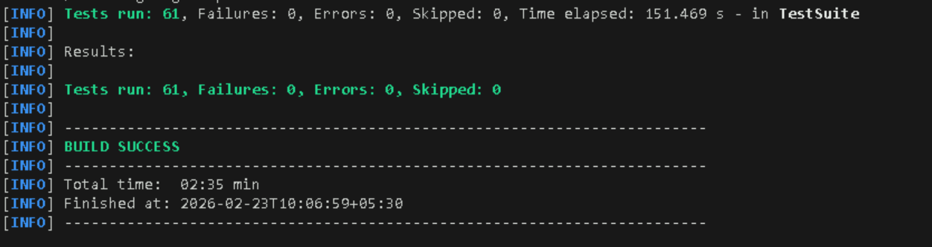

Allure Report

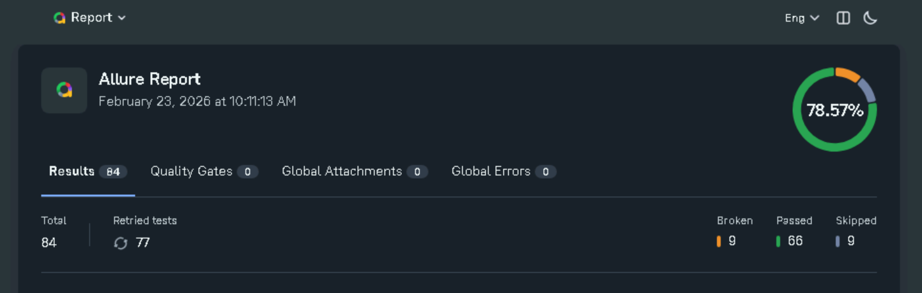

Light House Performance Test

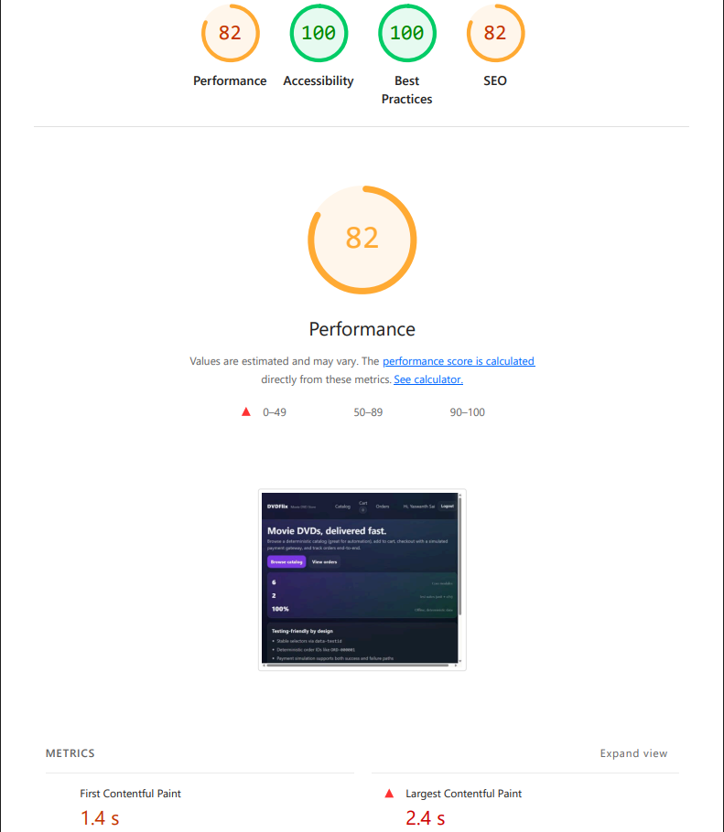

APACHE JMETER SUMMARY REPORT

